***REPORT***

*AUTOMATION EXPO 2018*

Title of Visited Project 1:

**4-Axis Cooperative Robotic Arm**

Why I chose this project :

**Dobot** is a brand of robotic arms produced by Shenzhen Yuejiang Technology Co., Ltd. DOBOT M1 is a cost-effective intelligent robotic arm for light industry. With high precision, wide working range, complete functions and secondary development, it provides users more ways to use. M1 can realize multiple functions of assembly line work such as soldering, visual recognition and PCB plug-in, helping to construct the intelligent industrial system. The repetitive positioning accuracy of M1 can reach 0.02mm, the maximum working range is 400mm, and the maximum load is 1.5kg, so as to ensure the best use effect of the lightweight industrial robotic arm.

**Views on project:**

No complex installation is required, M1 can be connected just in one step. It’s so light that a single person can move anytime anywhere.

Compact design enables M1 to truly realize the integration of drive control, greatly improving the working efficiency between servo drive and control system.

The repetitive positioning accuracy of M1 can reach 0.02mm, the maximum working range is 400mm, and the maximum load is 1.5kg, so as to ensure the best use effect of the lightweight industrial robotic arm.

The simple and concise mechanical structure enables M1 to work efficiently and it’s perfect for various assembly line work.

Standardized intelligent interface and open programming language make M1 highly extensible. With different accessories, M1 can realize diverse functions.

With lightweight body, easy installation and various controls, M1 can help you quickly complete the work including production and packaging.

**Project 1 :**

**4-Axis Cooperative Robotic Arm**

Dobot Master 1st generation robotic arm (Dobot M1 for short) focuses on the light industrial

market with great potential, and supports teaching, playback, script control, blockly graphic

programming, laser engraving, 3D printing, vision identity and other functions, which is flexibly

used in intelligent sorting, circuit board soldering and other automatic production lines, so that it

can become the sword to solve practical problems for light industrial users, and can also become the

platform to carry the imagination of the maker. Dobot M1 has the following characteristics

The integrated design of the driver and controller without external controller simplifies

the process of the initial installation and deployment**.**

The perfect calibration of servo motor, harmonic reducer and kinematic algorithm inside

Dobot M1 bring out the best of strength and speed.

The maximum load is 1.5kg, and the repeatability is 0.02mm.

Various I/O and communication interfaces are provided for secondary development.

Working Principle

This topic describes the workspace, principle, size, and technical specifications of Dobot M1.

Workspace

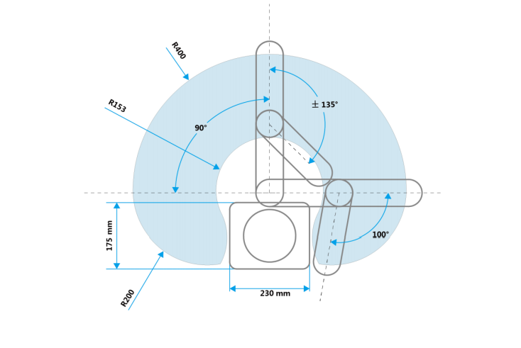

Dobot M1 has two types of coordinate system, the joint one and the Cartesian one.

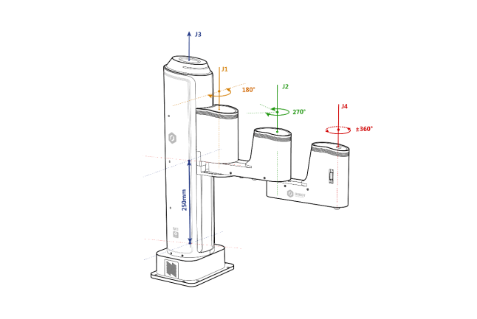

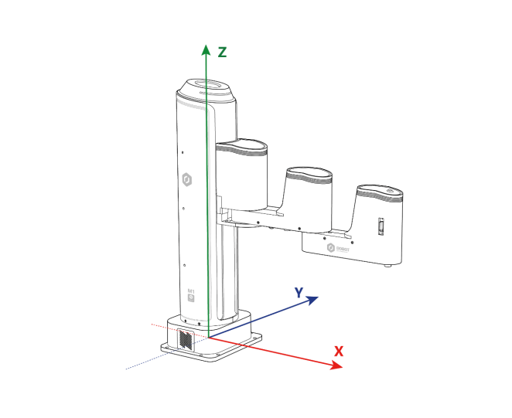

Arm Orientation

With two types of arm orientation (lefty hand orientation and righty hand orientation),

Dobot M1 can move to nearly any position and orientation within a given work envelope. You

need to specify the arm orientation when Dobot M1 is moving. If you fail to do so, Dobot M1

may move following an unexpected path, resulting in interference with peripheral equipment.

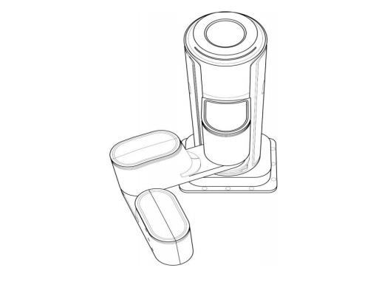

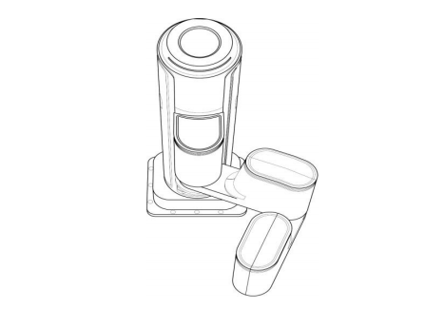

**Scope of Project:**

Robotic Arms has a wide scope of development. In the near future the arms will be able to perform every task as humans and in much better way. Imagination is the limit for its future applications. ... BCI can be used to acquire signals from the human brain and control the arm.

**Photographs :**

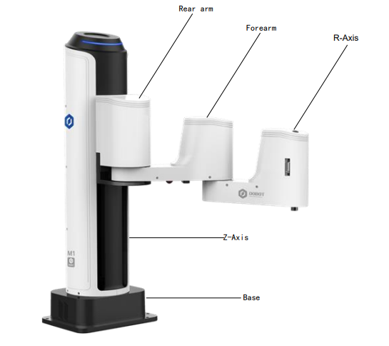

Appearance and Constitute

Dobot M1 consists of base, Z axis, Rear Arm, Forearm and R axis.

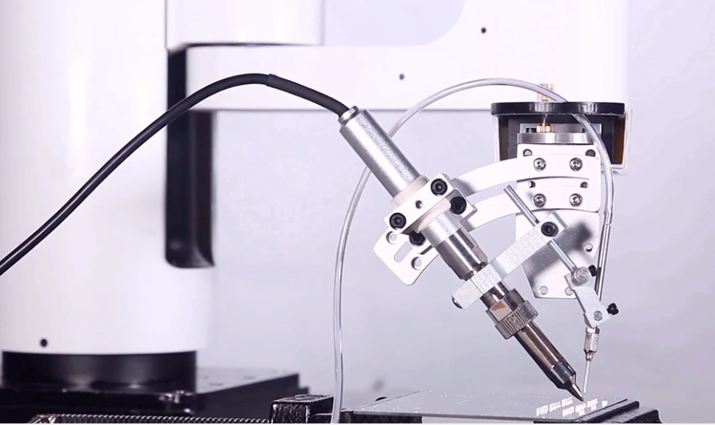

Soldering

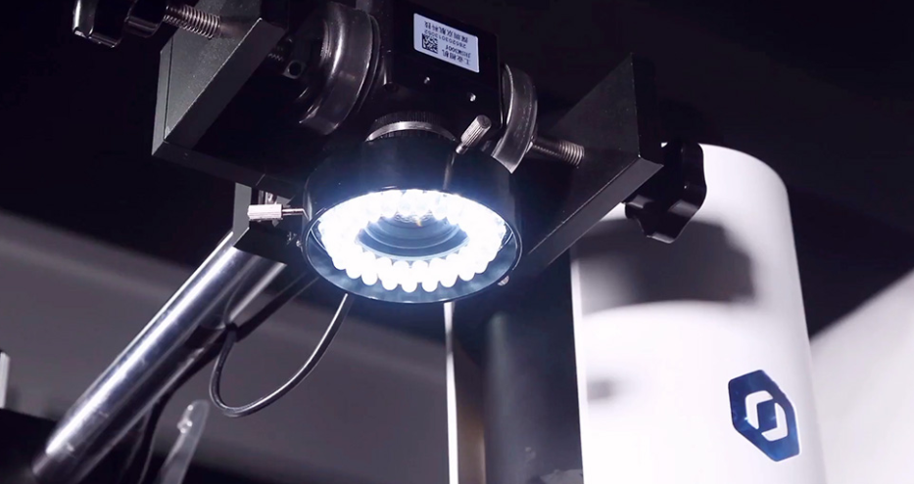

Factory inspection

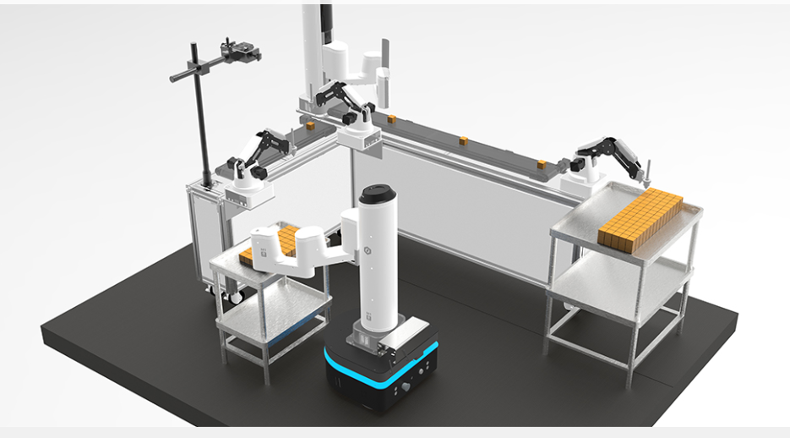

Packing

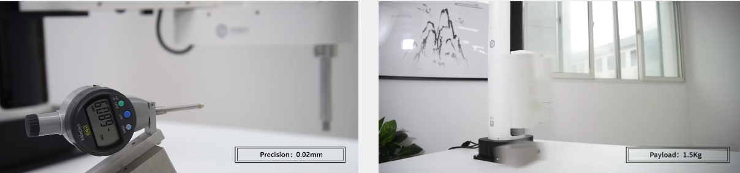

**Conclusion :**

Robots arms , many areas are developable. Thanks to the robotic arm , many taska are made easier and resulting error level has been reduced to minimum.

Robots help people with tasks that would be difficult, unsafe, or boring for real person to do alone. To conclude robotic arm is probably most mathematically complex robotic part one could ever build.

In future robotics will makes it possible for billions of people to have lives of leisure instead of the current preoocuption of materials needs.

Title of Visited Project 1:

FARO® Edge Arm

Why I chose this project :

Because of the following features:

Simplified user experience

Enhanced ergonomics, less fatigue

Quick measurements without a

computer

Diagnose setup issues affecting

performance

Improved reliability and capability

**Views on project:**

Single point articulation performance test (Max-Min)/2: The probe of the FaroArm is placed within a conical socket,Q and individual points are measured

from multiple approach directions. Each individual point measurement is analysed as a range of deviations in X, Y, Z. This test is a method for determining

articulating measurement machine repeatability.

2 Volumetric maximum deviation: Determined by using traceable length artifacts, which are measured at various locations and orientations throughout the working volume of the FaroArm. This test is a method for determining articulating measurement machine accuracy.

Project 2 :

Smart Sensor Technology

Warn against excessive external loads, correct

for thermal variations, and detect possible

setup problems

Smart Connectivity

Through Bluetooth, WiFi, USB, and Ethernetready

options. Enables multiple device management

through enhanced networking

Smart Multi-Function Handle Port

Quick-change handle and expandable

capability for seamless and interchangeable

accessory integration

Ergonomics

Improved weight distribution and balance, for

reduced strain and ease-of-use.

Multi-Probe Capability

Including standard, touch, FARO iProbes, and

custom probes

Intuitive On-Board Measurement System

Built-in touchscreen computer for laptop-free

basic measurements. On-board diagnostics

and easy-to-setup measurement routines

Scope of the project:

Aerospace: Alignment, tooling & mould certification, part inspection

Automotive: Tool building & certification, alignment, part inspection

Metal fabrication: OMI, First Article Inspection, Periodic Part Inspection

Moulding/tool & die: mould and die inspection, prototype part scanning

Photographs:



Full View of Arm

 Multi Functional handle port

Sensor Detect Overload Problem

Display Board

Conclusion:

The Edge is the most advanced, state-of-the-art FaroArm® ever introduced.

It is the first ever smart measurement arm featuring an integrated personal

measurement assistant. With its built-in touchscreen and on-board operating

system, the Edge revolutionizes portable metrology by providing standalone

basic measurement capability. The FARO Edge simplifies the user experience

with improved performance, portability, and reliability. Improve

production, quality, and reverse engineering processes by rapidly verifying

or scanning parts with confidence and accuracy using the FARO Edge.